Oshada Perera – CB012024

WDOS Assignment – 1

Wireframe – Save The Turtles

1. Home page
2. Turtle Categories
3. Hikkaduwa Turtle Hatchery
4. Threats To Turtles
5. Kosgoda Turtle Hatchery
6. Bentota Turtle Hatchery
7. Donate
8. Booking
9. Reviews
10. 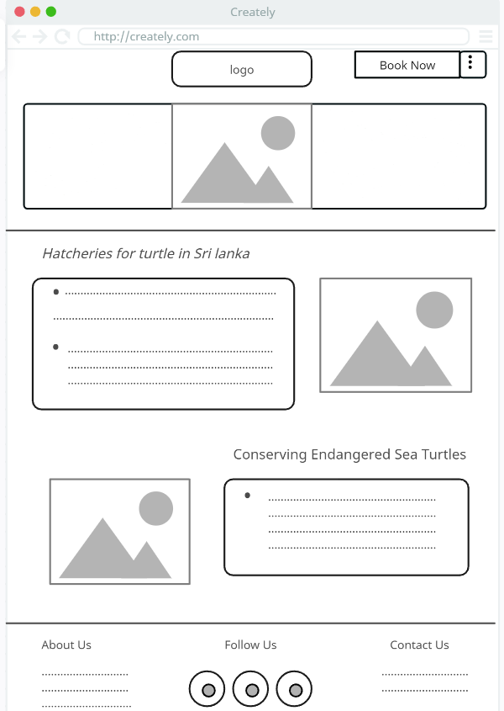Home page - 01
11. Home Page - 02

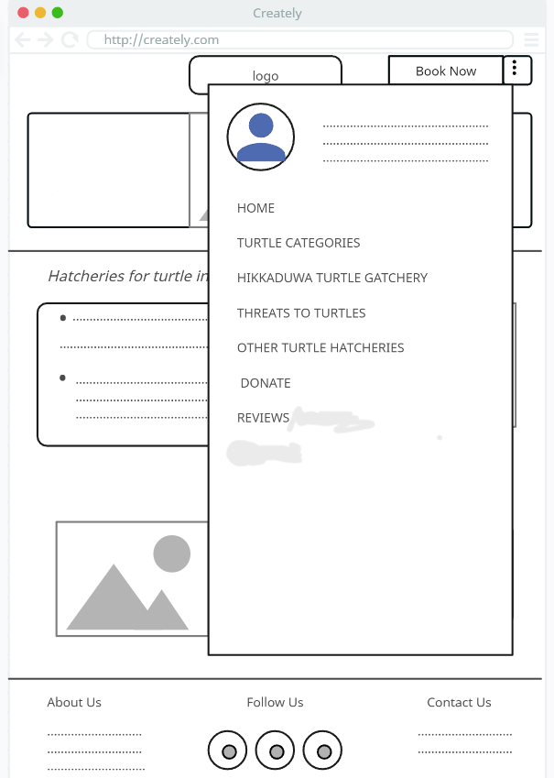



1. 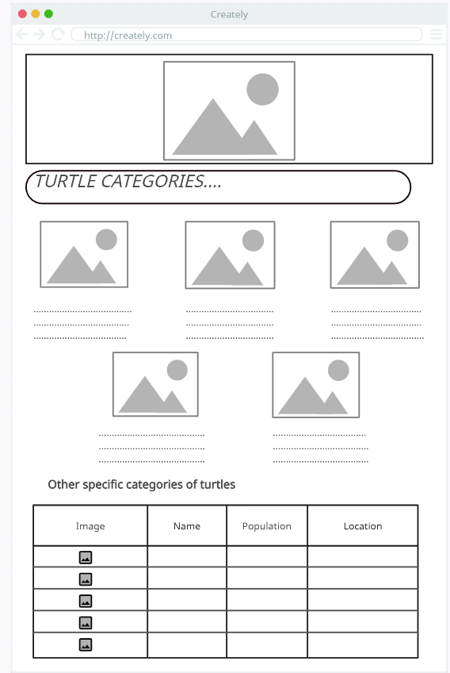Turtle Categories
2. Hikkaduwa Turtle Hatchery

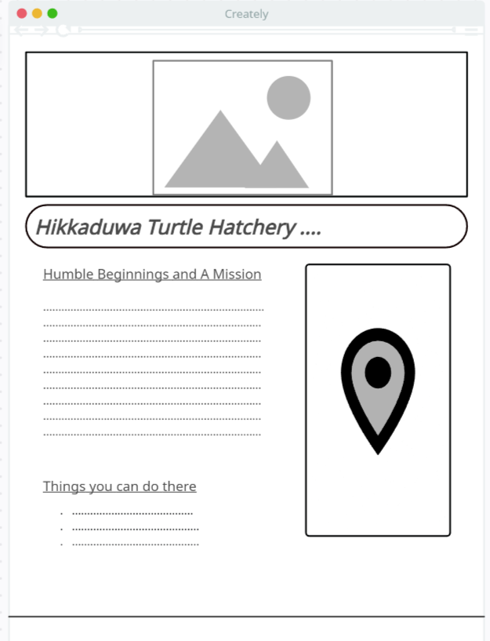

1. Threats to turtles

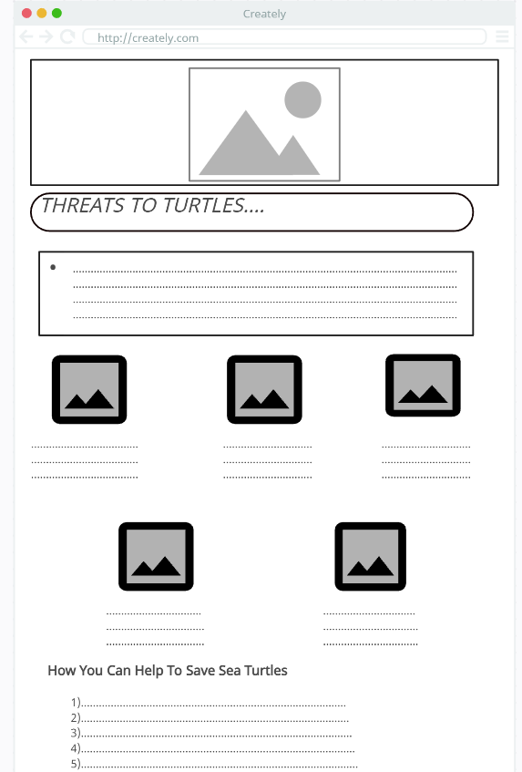

1. Kosgoda Turtle Hatchery

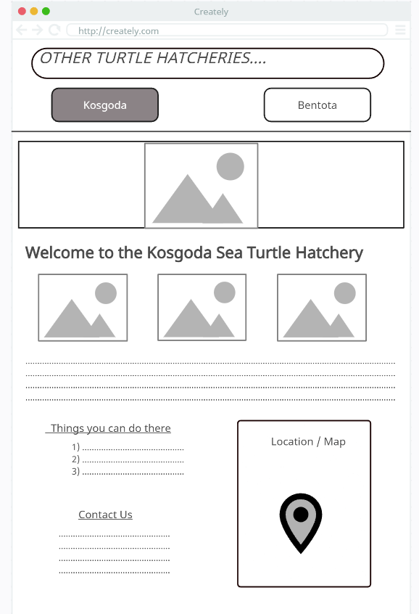

1. Bentota Turtle Hatchery

1. Donate

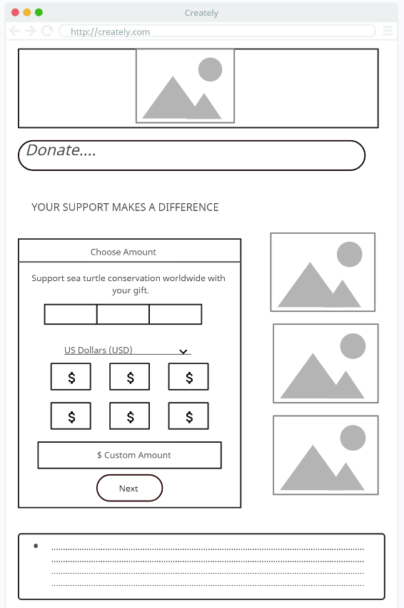

1. Booking

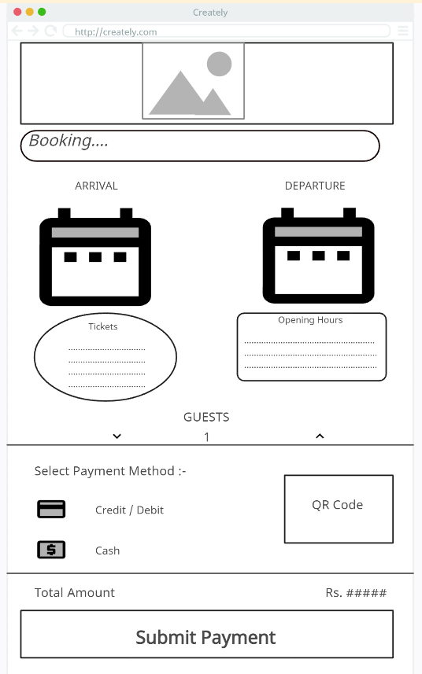

1. Reviews

